Lab: Configuring OSPF Routing
Objective
The overall objective of this laboratory exercise is to gain experience with configuring OSPF routing between two routers. In this lab, you gain an introductory understanding of the following:
1. Configuring the computer’s IP address
2. Configuring the gateway address
3. Configuring the IP addresses for the router interfaces
4. Configuring OSPF routing
5. Troubleshooting any configuration problems
Topology
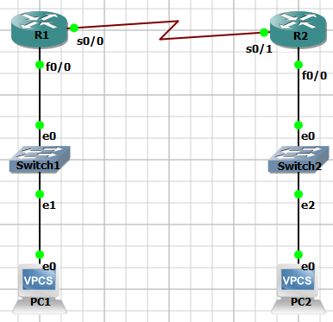
Figure 1:The Network Topology for This Lab
Key Concepts
The following concepts, terms, commands, and steps should be mastered in this laboratory exercise.
1. How do you configure the IP address, subnet mask, and default gateway for the computers in your LAN?
2. How is the gateway address for your LAN router configured?
3. What are the steps to configure the hostname for your router?
4. What are the steps to configure the router interface’s IP addresses and subnet masks?
5. What are the commands to configure OSPF routing from LAN-A to LAN-B?
6. What are the two commands that can be used to verify that the routes are configured on the router?
7. Use computers in your LAN to ping the computers in the adjacent LAN.
8. Use the proper command to trace the route from a PC in LAN-A to the host in the connected LAN-B.
9. Using the command to establish a telnet connection to your router, how can you enable a telnet connection to the router?
10. What is the router command that displays the network routes stored in your router’s routing table?
11. What is the command used to save your router configuration to NVRAM?
12. What is the command used to verify the routing protocol being used?
13. What is the command that displays only the OSPF routes?
14. What is the purpose of wildcard bits or inverse mask bits?
Reference Tables
For convenience, Table 1 provides the IP address and mask of all necessary interfaces used to complete the lab.
Table 1: The Computer IP Addresses, Subnet Masks, and Gateway Address for Lab 4
Computer/Interface – R1 | IP Address | Subnet Mask | Gateway Address
PC1 | 172.20.15.8 | 255.255.255.224 | 172.20.15.1
R1-Fa0/0 | 172.20.15.1 | 255.255.255.224 | ------------------
R1-S0/0 | 10.10.1.1 | 255.255.255.252 | ------------------
Computer/Interface – R2 | IP Address | Subnet Mask | Gateway Address
PC2 | 192.168.25.21 | 255.255.255.224 | 192.168.25.16
R2-Fa0/0 | 192.168.25.16 | 255.255.255.224 | ------------------
R2-S0/1 | 10.10.1.2 | 255.255.255.252 | ------------------
The commands used in these labs are based on the following Cisco IOS versions:
Router: Cisco IOS Version 12.4(7h)
Detailed Lab Steps
In the following tasks, you are given the opportunity to demonstrate your knowledge of configuring computer networks. Each task specifies a particular network setting you will be required to input. You will be required to document the command(s) used to accomplish each task.
Task #1
In this lab you configure an OSPF route to the adjacent LAN for the network shown in Figure 1. You will be required to verify that computers in your LAN can ping the neighbor LAN. Note that a serial interfaces is used to interconnect the LANs. You are configuring routing for both 172.20.15.0 and 192.168.25.0 networks. A subnet mask of 255.255.255.224 is used. Use 56000 for the clock rate on the serial link (DCE interface).

1. Configure the gateway address for FastEthernet 0/0 and the serial s0/0/0 interfaces on Router R1. Use the IP address and subnet mask specified in Table 1. You need to enable each interface and set the clock rate on the serial interface to 56000. List the router prompt and command used to configure the interfaces.
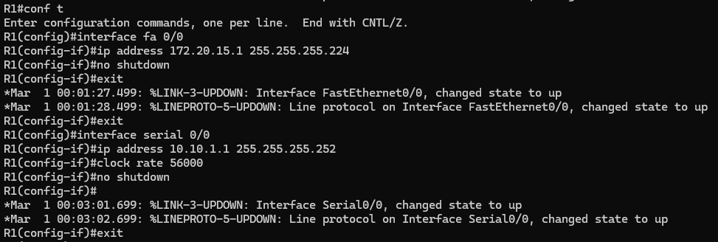
2. Configure the gateway address for FastEthernet 0/0 and the serial s0/0/1 interfaces on Router R2. Use the IP addresses and subnet mask specified in Table 1. Enable each interface, and list the router prompt and command used to configure the interfaces.
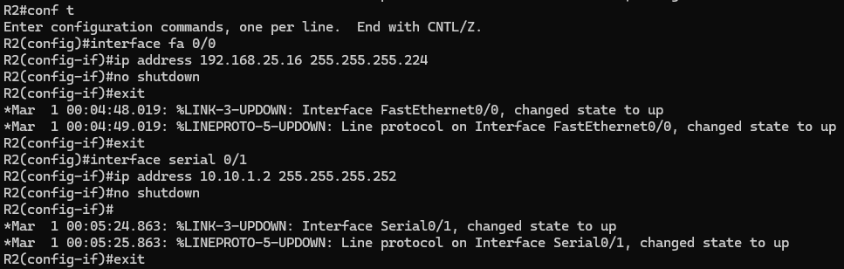
3. Configure the hostname for your routers. R1 should be renamed LAN-A, and R2 should be renamed LAN-B. List the router prompt and command used to configure the router’s hostname.
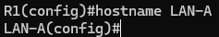
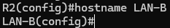
4. The proper command to verify that the interfaces on the LAN-A and LAN-B routers have been properly configured. List the router prompt and command used to configure the router’s hostname.
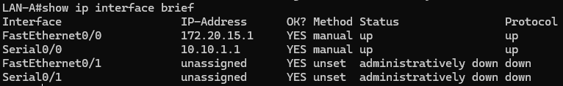
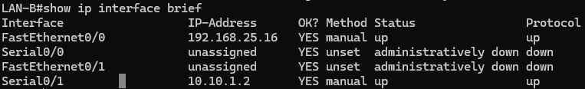
5. Configure OSPF routing between the LAN-A and LAN-B routers using a process ID of 100 and an area of 0. Use two commands to verify that the routes are configured. List the router prompt and command used to configure the LAN-A and LAN-B router.
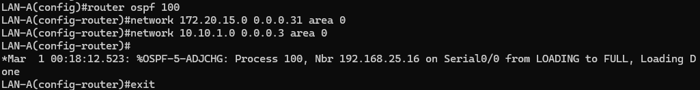
6. Use the proper command that displays the routing table for both the LAN-A and LAN-B routers. Are all the possible network routes displayed? List the router prompt and command used to display the routes.
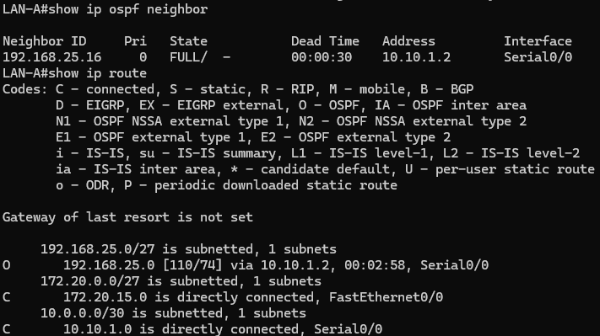
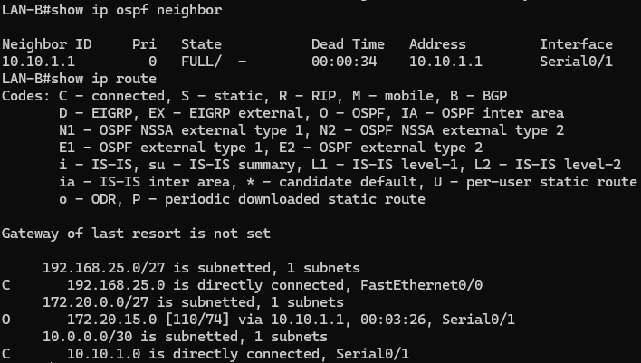
7. Use the computers in each LAN to ping the computers in the adjacent LAN. List the command used to ping the computer in the adjacent LAN.
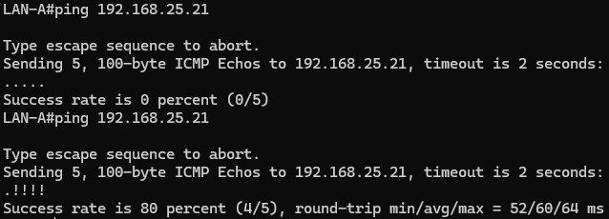
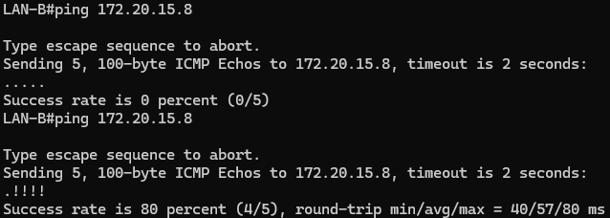
8. Use the proper command to trace the route from the PC in LAN-A to the PC in LAN-B. Your trace should pass through two routers. List the command used and record the trace information. How may hops did you record?
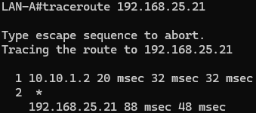
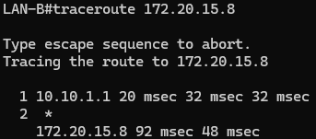
9. Use the command to save your router configuration to the startup configuration. What command did you use? Use the proper command to verify the configuration has been saved to NVRAM. List the command prompt and the command used?
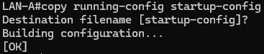
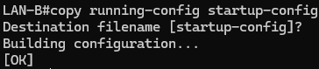

10. What is the command that is used to verify the routing protocol is being used? List the command prompt and the command used. Note that there are two commands that can be used.
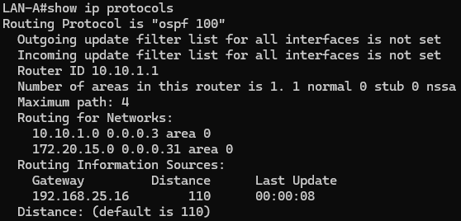
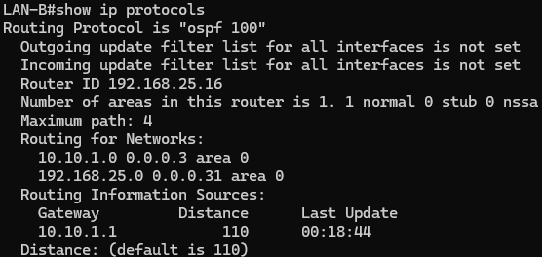
Task#2
Answer the following questions about the Cisco IOS.
1. The command prompt changes on a Cisco router to reflect the current state the router is in. Define what each command prompt listed represents.
a. Router>
User EXEC mode
b. Router#
Privileged EXEC mode
c. Router(config)#
Global Configuration mode
d. Router(config-if)#
Interface Configuration mode

e. Router(config-router)#
Router Configuration mode
f. Router(config-line)#
Line Configuration mode
Task #3: Configuration List
The following is a partial list of the items you might see when you issue the command show running-configuration [sh run]. Your task is to define each item and its purpose. You might need to go to Cisco.com to look up what each of these commands means.
1. ip cef
This command checks the address(es) that have Cisco Express Forwarding enabled on the current router. A Layer 3 IP switching technology that optimizes network performance.

2. no ip domain lookup
Tells the router to stop interacting with any DNS servers entirely, especially if attempting to resolve mistyped commands as domain names.

3. log-adjacency-changes
This command tells a router to create a log message when the adjacency relationship between two OSPF router changes. Helps monitor and troubleshoot changes in router adjacencies.

4. control-plane
This command enables access control and security features on the router's control plane, which manages router functions. It protects the router’s processing and management resources by controlling the traffic

5. scheduler allocate 20000 1000
This is a command to change the amount of time that the CPU spends on fast-switching and process-level operations, balancing CPU resources between data and control tasks.

6. description <--- >
This command is meant to provide a reminder in the configuration to describe what certain interfaces are used for. This can aid in network management and troubleshooting.

Answer the following router questions.
1. What command is used to determine the version of the Cisco IOS?
show version

2. What version of IOS is running on the LAN-A router?
Version 12.4(3)

3. What command is used to display the routing protocols configured on your router?
show ip protocols
4. What information is displayed when the command show start is entered?
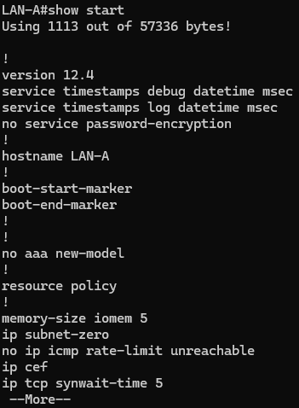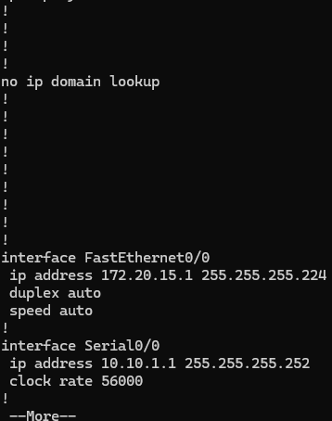
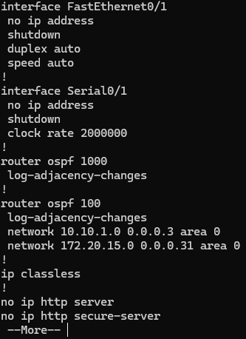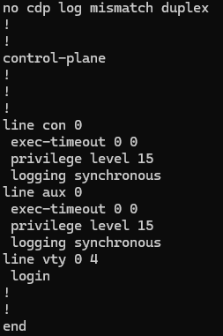
Displays the start up configuration file.

5. What router command is used to determine if your serial interface is DTE or DCE?
show interface serial [serial port]

6. What is the command for setting the clock rate on a router’s DCE serial interface to 56000?
clock rate 56000

7. How long has it been since your router was last rebooted? Indicate how the system was restarted. Note: There is a Cisco command that provides this information. Cisco calls this the router uptime. The same command also specifies how the system was restarted.

LAN-A uptime is 16 minutes
System returned to ROM by unknown reload cause - suspect boot_data[BOOT_COUNT] 0x0, BOOT_COUNT 0, BOOTDATA 19

